Answer 5
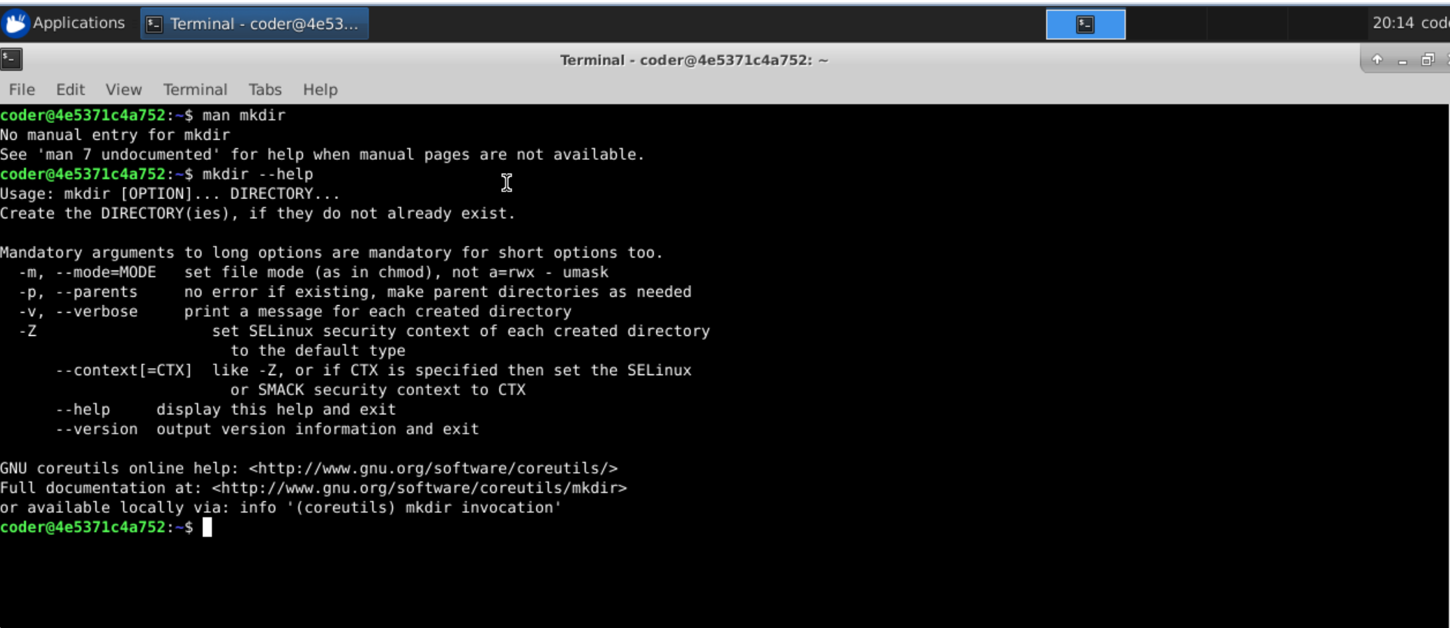
Explanation: The command supposes to be is man mkdir, but for some reason its doesn’t work so the way around is using --help option with the command mkdir this will give you output from man command. Now let’s see option -m with mkdir will allow us to set the permissions for the directory we are creating using mkdir command. Example: mkdir -m 777 e1

